# Lecture 1: 02/07/2022 (watched 03/07/2022)

* introduction into Ashris’ life, how he led himself to data visualisation and @india_in_pixels
* history of data visualisation, physical graphs and maps
* the value of conveying story + facts over conveying just facts / just stories.
* 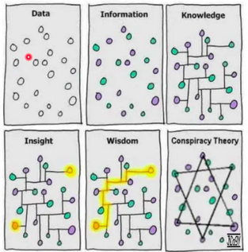going through different kinds of visualisations, and understanding how efficient they are at conveying their information

# Lecture 2: 03/07/2022

* the meaning of data: information, knowledge, and wisdom
  + includes numbers, letters, expressions, and emotions
  + quantifying data is a task, not a way to define what data is
* visual representation of data is broader than graphing
  + eg. perfume scent → perfume bottle design
  + eg. digits of pi → a musical performance
* activity: visualising basic information about yourself in a drawing
* types of data:
  + 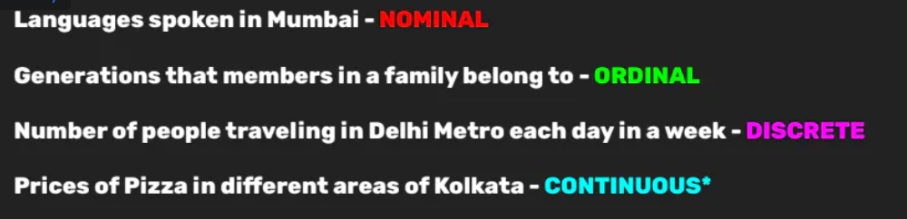 qualitative:
    - nominal: mutually exclusive
    - ordinal: has an order
  + quantitative:
    - discrete: fixed assortment of values
    - continuous: every integer is possible  
      can be contentious, eg. price, but is better to consider continuous
    - **percentage of discrete data remains discrete, despite seeming continuous**
* collection of data:
  + primary: collected specifically for this project
    - personal data
    - 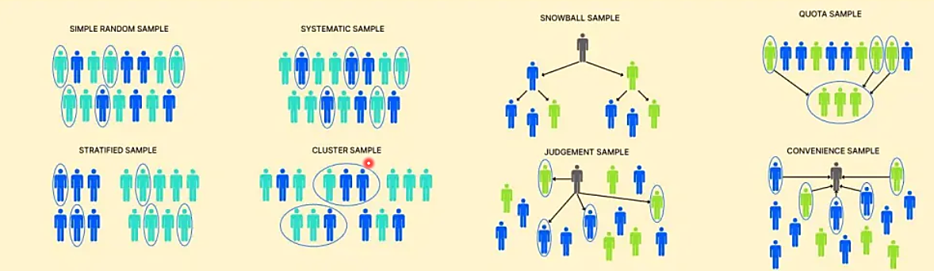forms, etc.: sampling methods
  + secondary: existing data
* examples of data visualisation: being open to creative ways: [*dear data, stephanie posavec*](https://www.goodreads.com/book/show/28465052-dear-data) (seems fun!!)
* cool websites:
  + [National Data and Analytics Platform's interface](ndap.niti.gov.in)
  + [aggregation of indian datasets by gurman bhatia](https://www.gurmanbhatia.com/idea/resources/2021/05/31/dataset-of-datasets-for-indian-journalists.html)
  + r/dataisbeautiful subreddit
  + [Information is Beautiful Awards](https://www.informationisbeautifulawards.com/)
  + Kaggle

Lecture 3: 09/07/2022:

* going through exercises
* Principle Component Analysis (PCA): converting existing features to new features
* dimensionality
  + reducing number of variables by creating an equation to predict the values instead
* basic excel tips and tricks

Lecture 4: 10/07/2022:

* benefits of programming
* editor.p5js.org
  + rect(x,y,width,length)
  + ellipse(x,y,width,length)
  + .fill(255,255,255)
* colours as hexadecimal codes, RGB, (255,255,255)
* coordinate geometry
* fibonacci sequence / golden ratio
* rule of thirds
* avoid centers
* weight of words
* movement
* comparability
* isolation / proximity
* framing
* visual cues
* symmetry / asymmetry
* level of detail
* repetition
* patterns
* rhythm
* gestalt principle
* continuation
* similarity
* closure
* negative / positive
* colour